 | TAKE A CARD... | NEW: 28 Nov 97  Rev.: 27 MAY 2009  Rev.: 2 JAN 2022

SUNSTAG(Reg.)  IRISH WOLFHOUNDS  Dixie J. Howell-Hirsch  Owner/Breeder/WorldwideExhibitor/  Conformation, Coursing, Int'l Level Judge | 10500 Christenson Road  Lucerne Valley CA 92356  Cell Phone: (949) 750-4193  Do Not Text!!  E-Mail: dixie@sunstag.org  Web: http://www.sunstag.org  Puppies Occasionally  Visits By Reservation Only
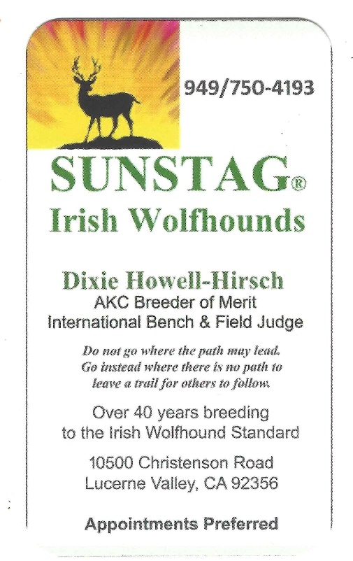
I just wanted to make it easy for you!
Print, Cut and Carry the bottom one!
Then, call and Let's Just Chat!

